Company Policy Statement

The VEKA UK Group specialises in the following:

- VEKA PLC – design, extrusion, lamination and supply of PVC-U window and door systems and other associated products
- Bowater Projects – management of survey and installation of windows and doors

Senior Management is committed to ensuring that our business practices comply with all legislative requirements, and takes every step available to us to ensure that the business and our supply chain is free from slavery and human trafficking, in accordance with the Modern Slavery Act 2015.
VEKA
Slavery
On an annual basis, VEKA undertakes an audit to ensure compliance of National Minimum and National Living Wage requirements for every age group.
VEKA ensures that employees’ working hours are managed in line with the Working Time Regulations 1998 and Road Transport Working Time Regulations 2005.
All overtime is conducted on a voluntary basis.

Human Trafficking
On an ongoing basis, VEKA ensures that each and every employee or temporary worker has the right to work in the UK in line with Home Office guidance for the Prevention of Illegal Working.

VEKA plc will ensure that all persons working for or on behalf of the Company are fully acquainted with the Company's policies and objectives through on-going training and education at all levels.

VEKA’s Supply Chain
It is the Company’s policy to ensure that members of our supply chain equally support our Company Values.
During 2017 VEKA will include declarations in all its supply and purchasing agreements and terms and conditions to request compliance in respect of legislation to prevent slavery and human trafficking.

Signed
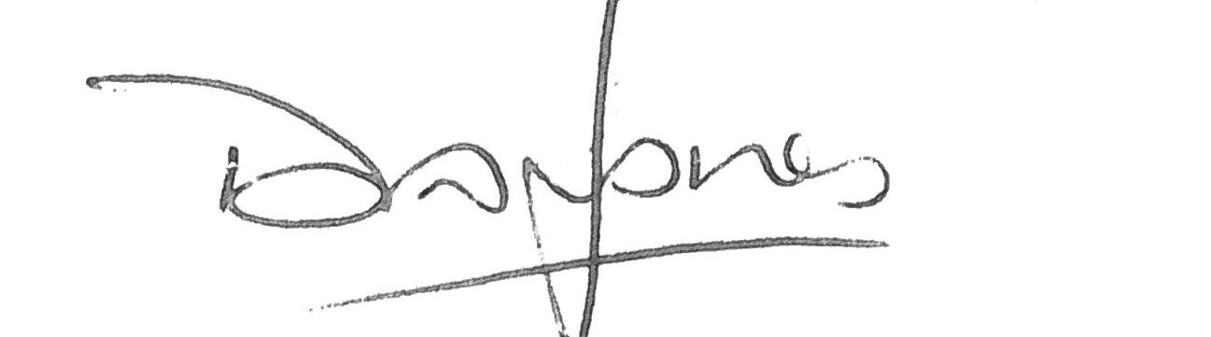
David Jones, Managing Director

January 2017

